**High Level Design (HLD)**

**Analyze International Debt Statistics**

**Revision Number - 1.0**

**Last Date of Revision – 03/10/2022**

**Document Version Control**

|  |  |  |  |
| --- | --- | --- | --- |
| **Date Issued** | **Version** | **Description** | **Author** |
|  |  |  |  |
| 03/10/2022 | 1.0 | Abstract, | Rushabh Halmare |
|  |  | Introduction, |  |
|  |  | General Description  Initial Documentation |  |
|  |  |  |  |

**Contents**

Document Version Control......................................................................................................... 2

Abstract........................................................................................................................................4

1. Introduction............................................................................................................................. 4

1.1 Why this High-Level Design Document? .............................................................. 4

1.2 Scope....................................................................................................................... 4

2. General Description ............................................................................................................... 5

2.1 Product Perspective & Problem Statement ............................................................. 5

2.2 Tools used ............................................................................................................... 5

3. Design Details .........................................................................................................................5

3.1 Functional Architecture ........................................................................................... 5

4. KPIs......................................................................................................................................... 6

4.1 KPIs (Key Performance Indicators) ........................................................................ 7

5. Deployment..............................................................................................................................7

**Abstract**

Governments, like individuals, may borrow money to manage their economies, finance budget deficits or capital projects, or meet the balance of payments or cost of national emergencies.   
[The World Bank](https://www.linkedin.com/company/the-world-bank/) is an international financial institution that provides loans and grants to the governments of low- and middle-income countries to pursue capital projects. In this project, we are going to analyze international debt data collected by The World Bank. The dataset contains information about the amount of debt (in USD) owed by developing countries across several categories.

**1. Introduction**

**1.1 Why this High-Level Design Document?**

The purpose of this High-Level Design (HLD) Document is to add the necessary detail to the current project description to represent a suitable model for coding. This document is also intended to help detect contradictions before coding and can be used as a reference manual for how the modules interact at a high level.

**The HLD will:**

* Present all of the design aspects and define them in detail
* Describe the user interface being implemented
* Describe the hardware and software interfaces
* Describe the performance requirements
* Include design features and the architecture of the project
* List and describe the non-functional attributes like:
* Security
* Reliability
* Maintainability
* Portability
* Reusability
* Application compatibility
* Resource utilization
* Serviceability

**1.2 Scope**

The HLD documentation presents the structure of the system, such as the database architecture, application architecture (layers), application flow (Navigation), and technology architecture. The HLD uses non-technical to mildly-technical terms which should be understandable to the administrators of the system.

HIGH LEVEL DESIGN (HLD)

**2. General Description**

**2.1 Product Perspective & Problem Statement**

The purpose of the International Debt Statistics is to provide comprehensive guidance for the measurement and presentation of external debt statistics. It also provides advice on the compilation of these statistics and on their analytical use. We are going to find the answers to questions like:

1. What is the total amount of debt that is owed by the countries listed in the dataset?
2. Which country owns the maximum amount of debt and what does that amount look like?
3. What is the average amount of debt owed by countries across different debt indicators?

The data used in this project is provided by The World Bank. It contains both national and regional debt statistics for several countries across the globe as recorded from **1970-2028**.

**2.2 Tools used**

Business Intelligence tools like Tableau is used to build the whole framework.

|  |
| --- |
|  |

**3 Design Details**

**3.1 Functional Architecture**

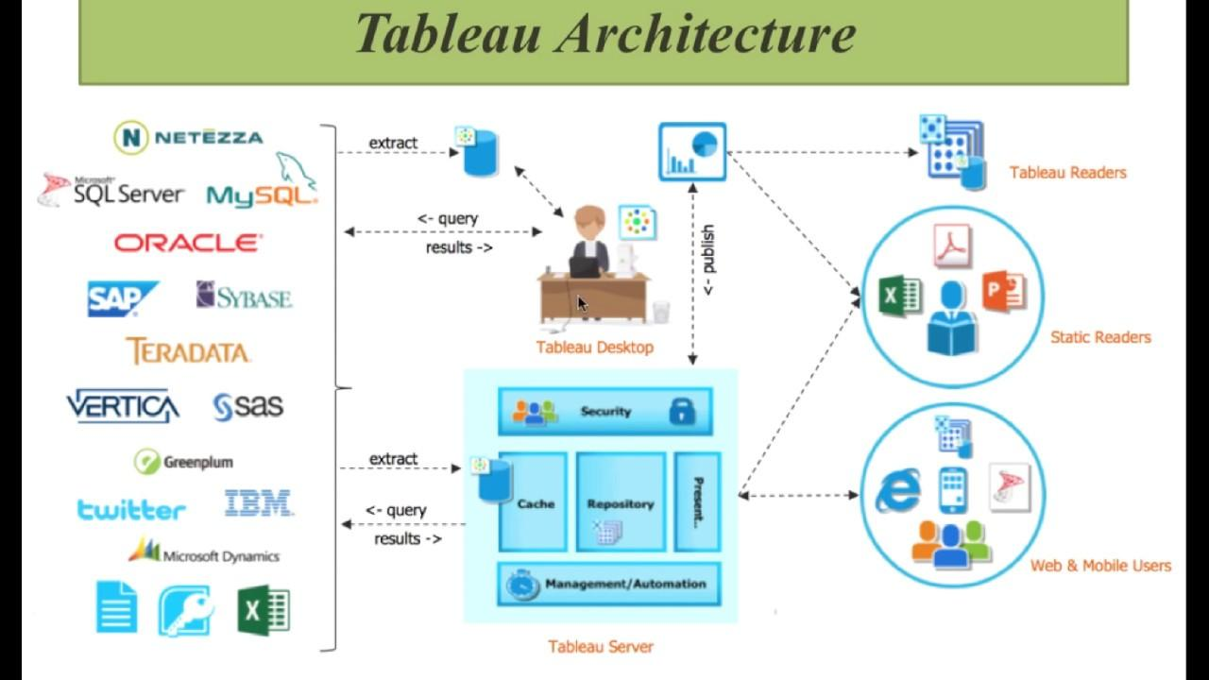

**How does Tableau Work?**

* The major work of Tableau software is to connect and extract the data stored in various places. It can pull data from any platform. Tableau can extract data from any database, be it [Excel](https://intellipaat.com/blog/another-collaborator-for-data-analytics-those-excel-sheets/), PDF, Oracle, or even [Amazon Web Services](https://intellipaat.com/blog/tutorial/amazon-web-services-aws-tutorial/).
* There are two types of data extraction-

1. Live
2. Extract.

* Live data connectivity is about extract data lively (online), an analyst will work on data and share a dashboard with the user. Users can read the data using the tableau reader.
* Data extraction can be done from Tableau Desktop (offline) and it is published on Tableau Server. Users can access data using the Tableau server from any location.

**Assumptions**

Our analysis assumes that all the data provided was true without any corruption and the features mentioned in the raw dataset are the only driving factors of an equilibrium.

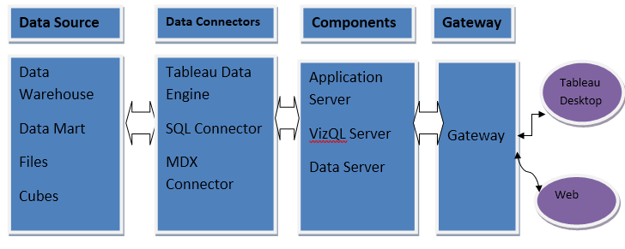

**4. KPI**

Dashboards will be implemented to display and indicate certain KPIs and relevant indicators for the International Debt.



As and when the system starts to capture the historical/periodic data for a Year, the dashboards will be included to display charts over time with progress on various indicators or factors

**4.1 KPIs (Key Performance Indicators)**

Key indicators displaying a summary of the International Debt Analysis and its relationship with different metrics

1. The World Bank's international debt data
2. Finding the number of distinct countries
3. Finding out the distinct debt indicators
4. Calculating the amount of debt owed by the countries
5. Country with the highest debt
6. Average amount of debt across indicators
7. The highest amount of principal repayments
8. The most common debt indicator
9. Other viable debt issues and conclusion

**5. Deployment**

Prioritizing data and analytics couldn’t come at a better time. With the explosive growth of enterprise data, database technologies, and the high demand for analytical skills, today’s most effective IT organizations have shifted their focus to enabling self-service by deploying and operating Tableau at scale, as well as organizing, orchestrating, and unifying disparate sources of data for business users and experts alike to author and consume content. Tableau prioritizes choice in flexibility to fit, rather than dictate your enterprise architecture. Tableau Server and Tableau Online leverage your existing technology investments and integrate into your IT infrastructure to provide a self-service, modern analytics platform for your users. With on-premises, cloud, and hosted options, there is a version of Tableau to match your requirements. Below is a comparison of the three types:

TYPE PROS CONS

**Tableau Server - On Premises**

* Full control of hardware and software
* Infrastructure and data remain behind your firewall
* Need dedicated administrators to manage hardware and software
* Additional infrastructure needed to access off-network (mobile, external)

**Tableau Server - Public Cloud (IaaS)**

* Full control of software on managed hardware
* Puts infrastructure in same place as data (for migration to cloud)
* Flexibility to spin up/down hardware as needed
* Need dedicated administrators to manage software.
* Additional infrastructure needed to access off-network (mobile, external)

**Tableau Online (SaaS)**

* Fully hosted solution (hardware, software upgrades)
* Fast to deploy
* Easy for external audience to access
* Single-site in multi-tenant environment
* Cubes are not supported
* No guest account access

The Dashboard is published on Tableau and an auto-refresh mode has been set so that the dashboard keeps on updating as the real time data loads into the log file.

The Dashboard showcases the multiple insights that has been drawn from the log files as follows:

**Country wise-** This dashboard contains **Country** wise Rank of Debt analytics on dataset Country name.

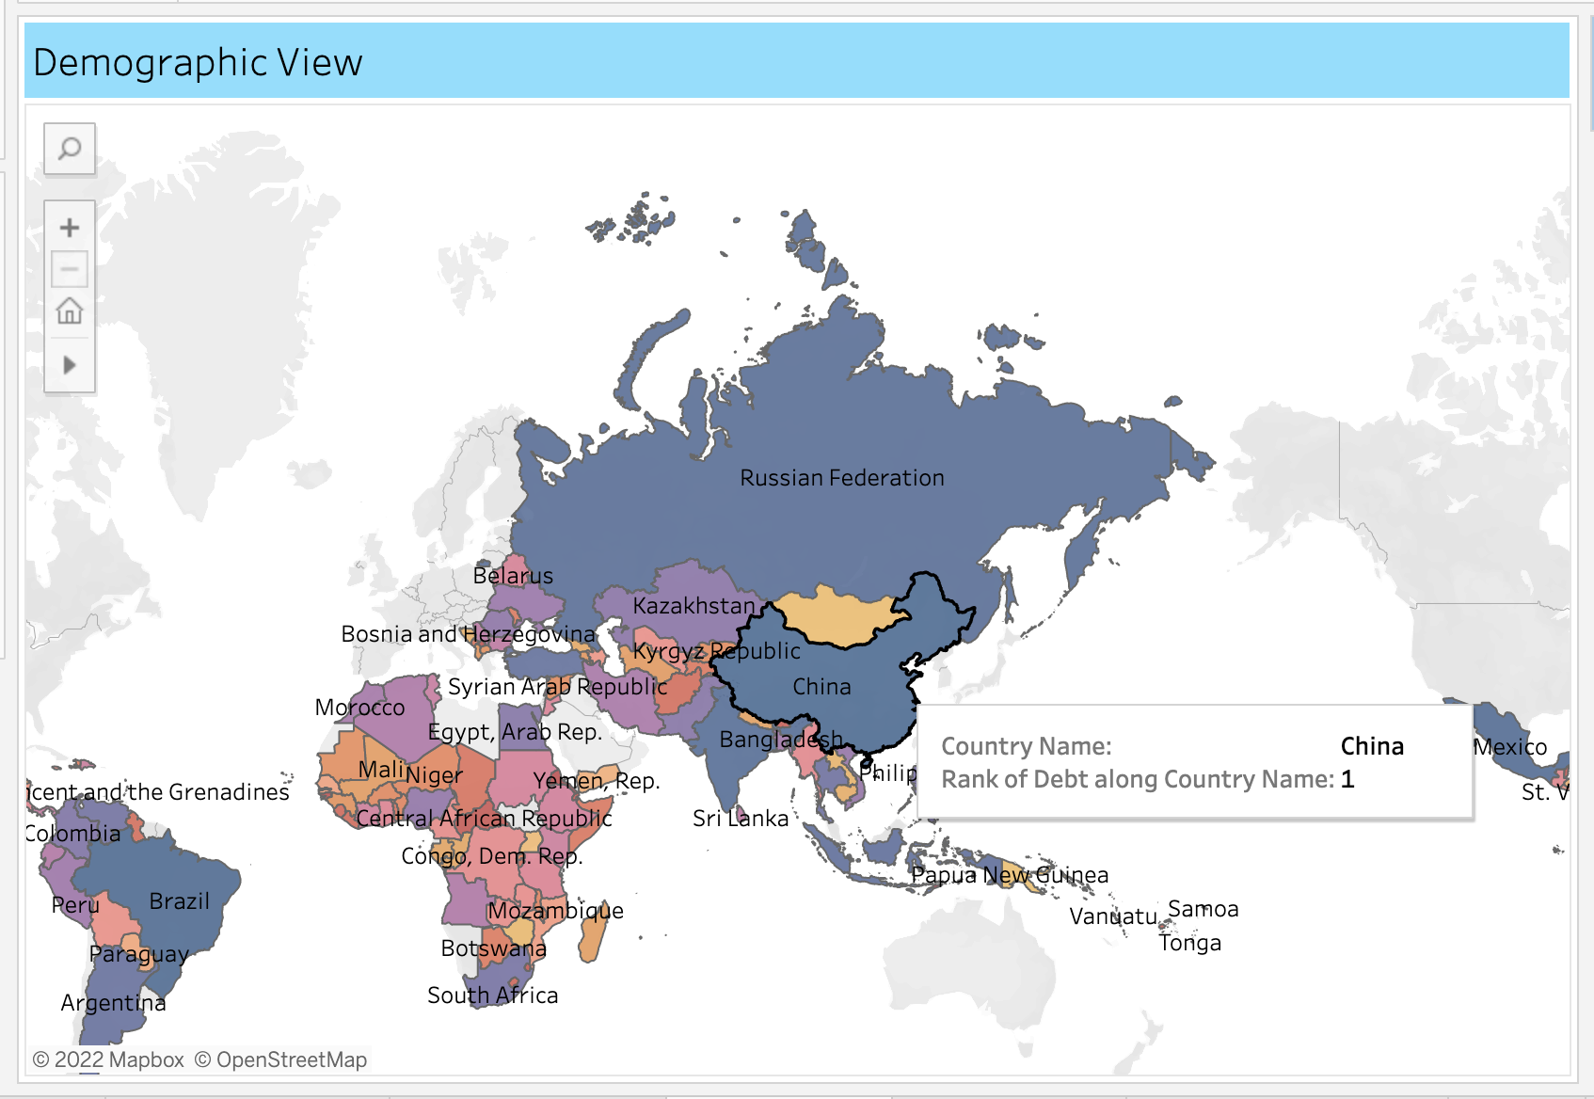

**Indicator wise:** Attached Screenshot displays indicator-wise which country has highest debt in each Indicator, given ‘HIGHLIGHT COUNTRY NAME’ and ‘HIGHLIGHT INDICATOR SERIES CODE’, using which we can find analysis for each Indicator Code of each Country

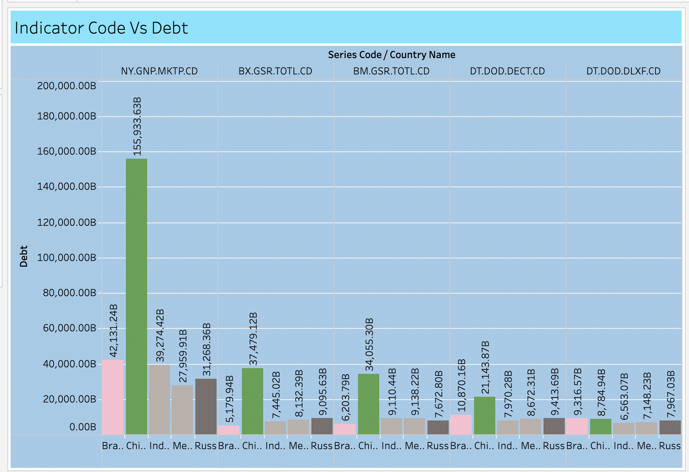

**Indicator Series Code:**

Attached Screenshot displays Indicator Series Debt wise.

